1) Create one Jenkins job using the below code and create three stages.

stage1: Git clone to download the source code.

stage2: Sonarqube Integration to check the quality of code

stage3: Slack Integration to send the alerts to slack.

URL: <https://github.com/betawins/VProfile-1.git>

Stage 1: Git clone  
Go to Jenkins Dashboard Click on New item  
Name : VProfile-1  
Freestyle project, Click on create   
Go to Description enter the description as VProfile app  
Come to Source code management and select .git  
Enter the repoistiory URL : https://github.com/betawins/VProfile-1.git  
 As it is public Repo no need to enter the credentials.  
Click on Save  
Click on Build Now, clone the project  
Once it is executed successfully, Go to Jenkins server  
Check for var/lib/jenkins/workspace/VProfile  
We will able to see all the source code downloaded from Git Repo

We have successfully cloned the Git. Means First stage is completed

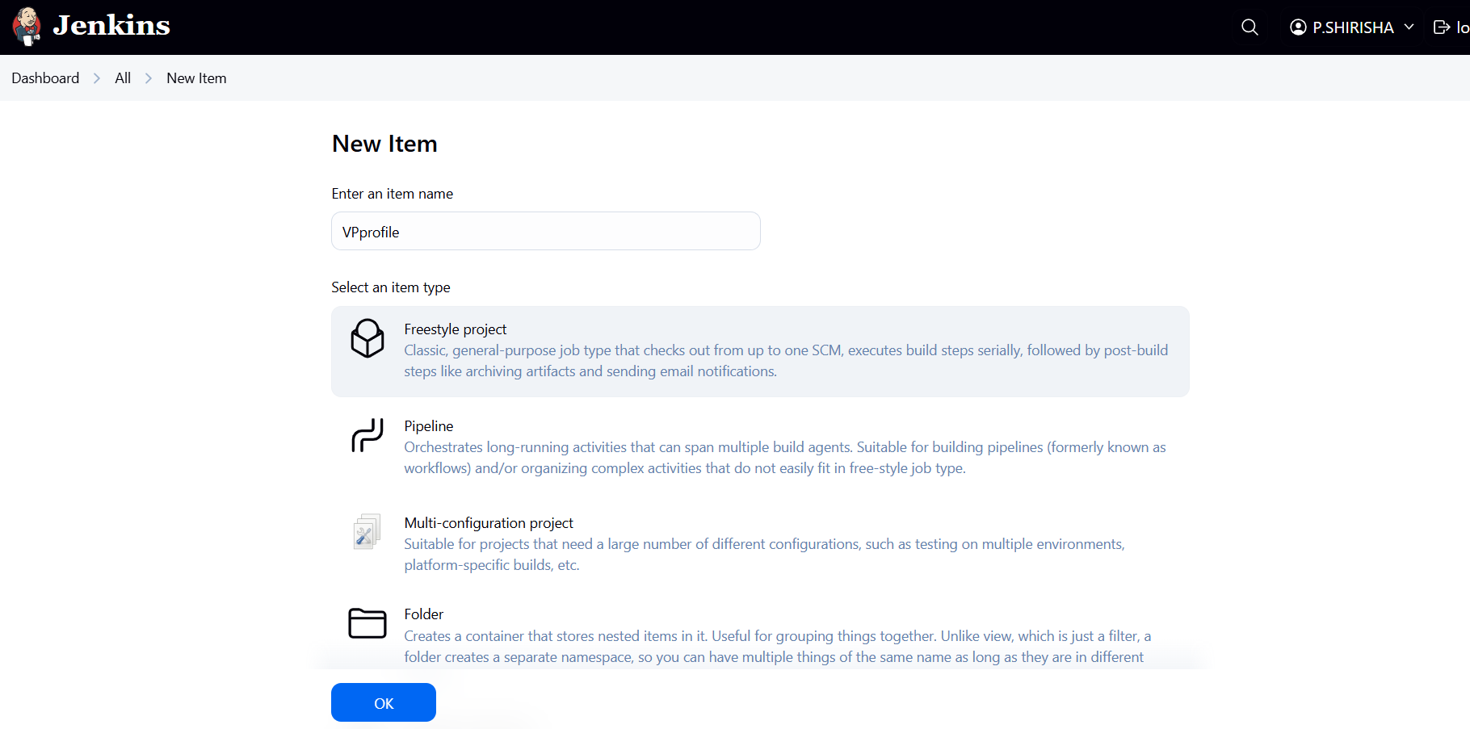

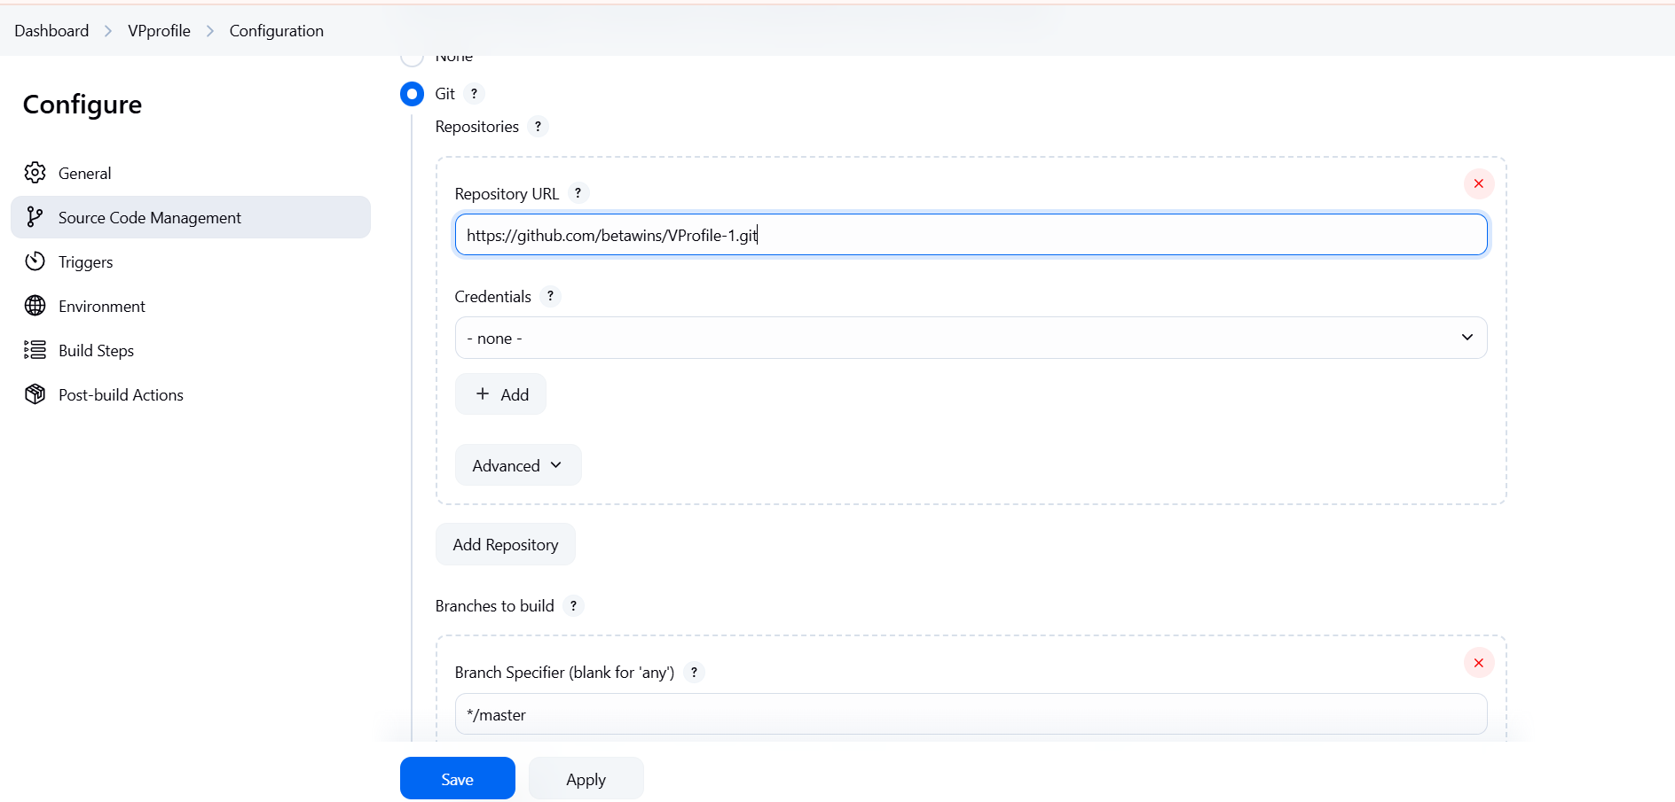

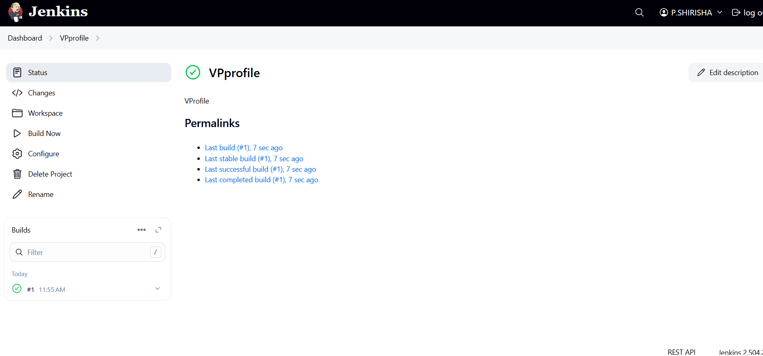

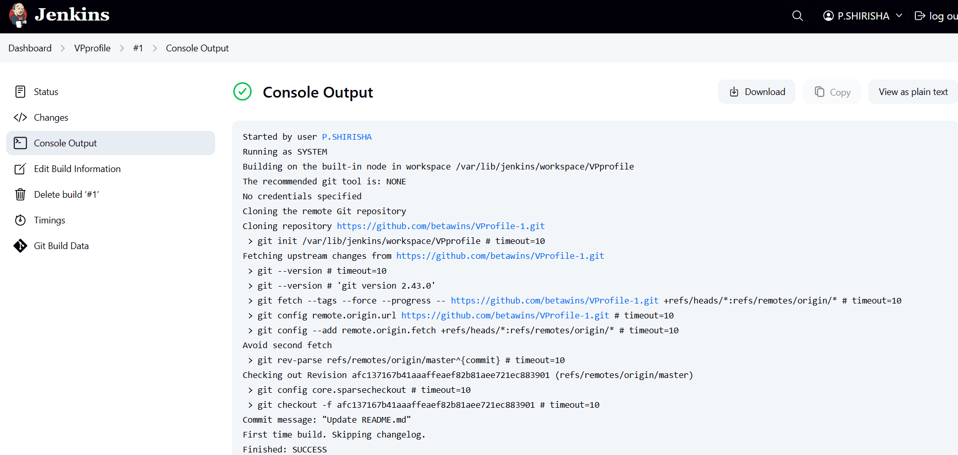

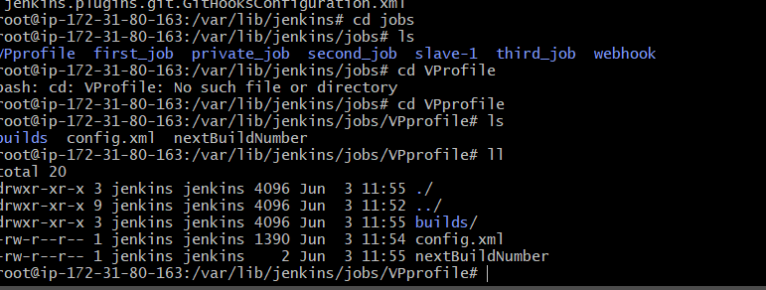

Stage2: SonarQube integration  
In order to integrate SonarQube we need to have one SonarQube Server  
SonarQube will check for the quality of source code which we have cloned from the repository.   
SonarQube Installation:  
Pre-requisites:

1. Ec2-instance with Java installed

2.Use t2.large with atleast 20GiB memory to run SonarQube  
3.MYSQL database server or MYSQL RDS instance  
First, we will launch one EC2 instance.  
Go to AWS console and EC2 dashboard and launch one instance  
Name: SonarQube-server  
image: ubuntu  
type: t2.large,  
Select Keypair and select default VPC and select default security groups  
Select the Size 20GB and Click on Launch instance.  
Once the instance is successfully up and running.  
Connect SonarQube server and switch to root user: Sudo su

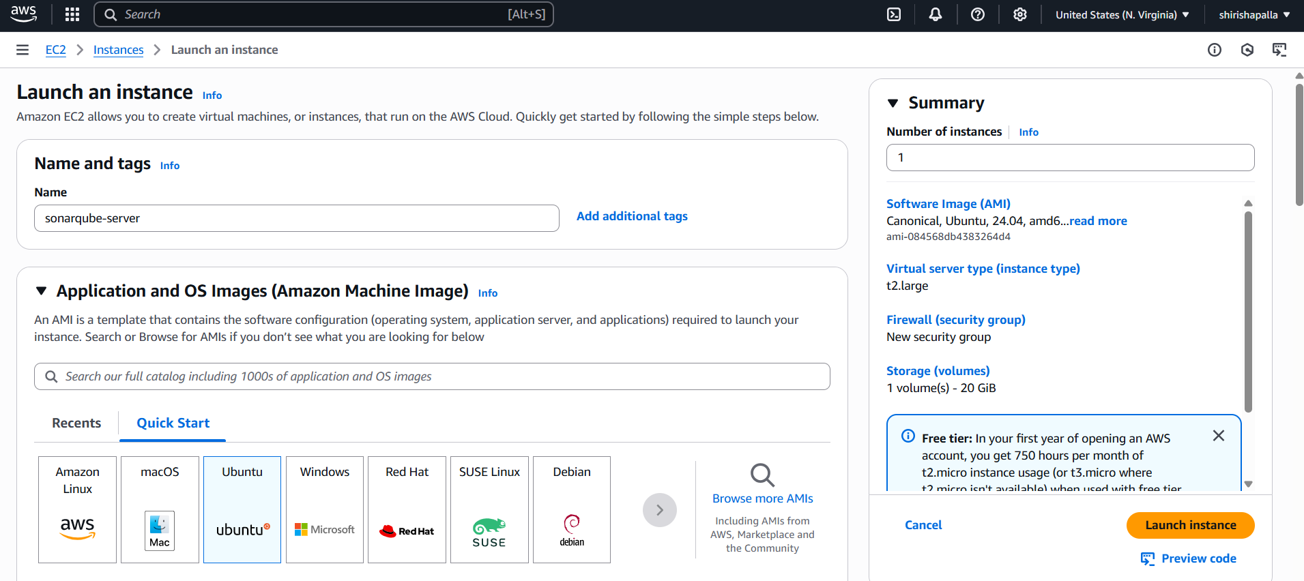

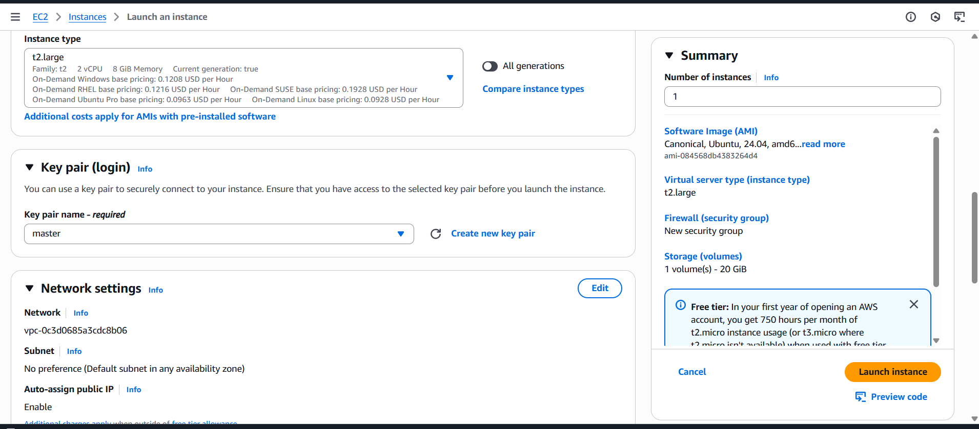

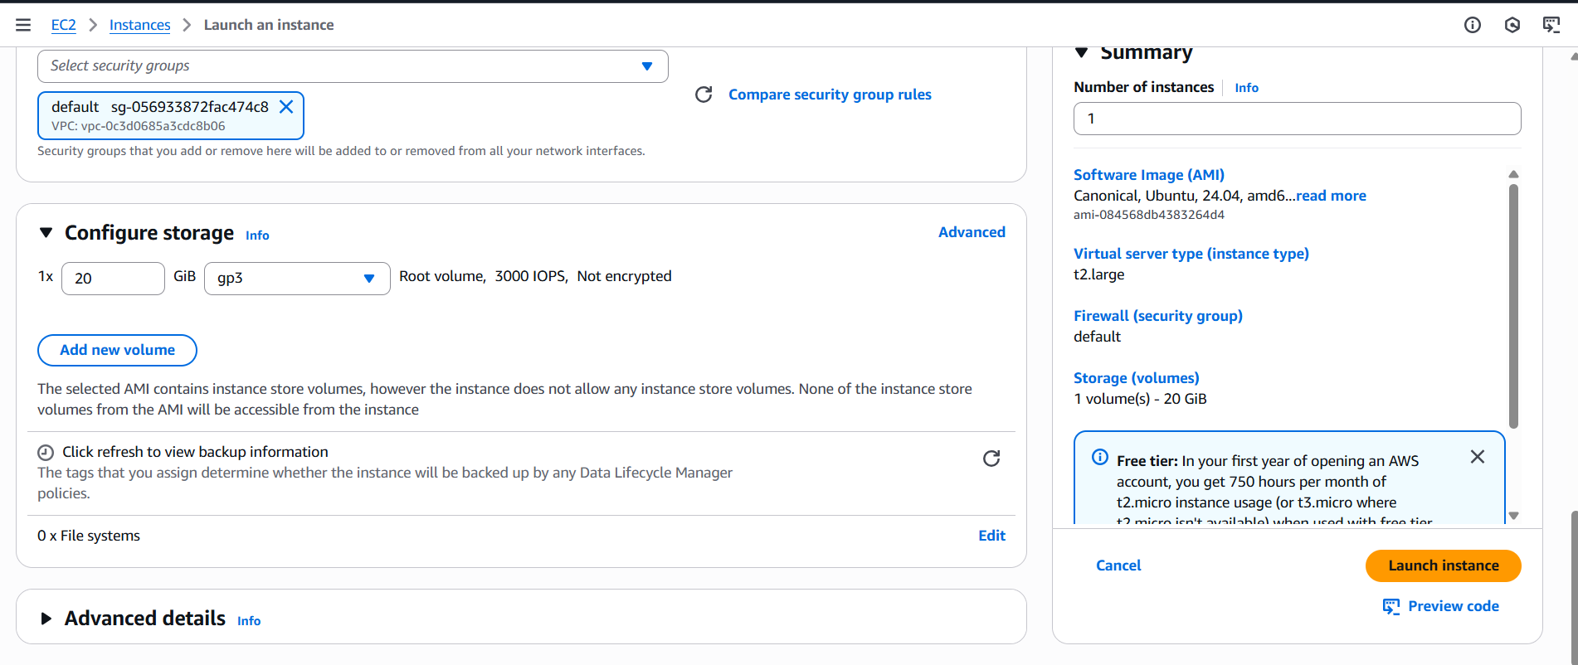

Install java:

sudo apt update

sudo apt install openjdk-8-jdk -y

java -version

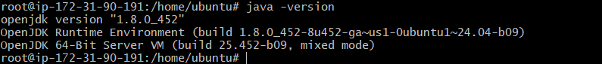

Install MYSQL:

sudo apt update

sudo apt install mysql-server -y

sudo systemctl start mysql

sudo systemctl status mysql

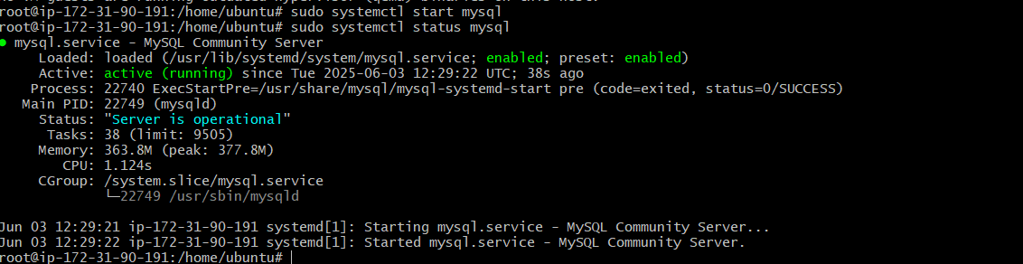

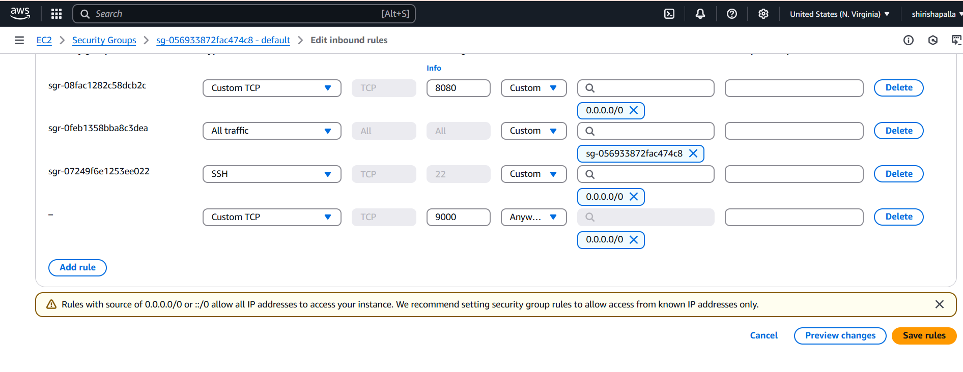

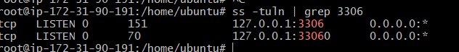

ALTER USER 'root'@'localhost' IDENTIFIED BY 'Admin@123';

FLUSH PRIVILEGES;

exit;

mysql -u root -p

New password Welcome to the MySQL monitor...

mysql>

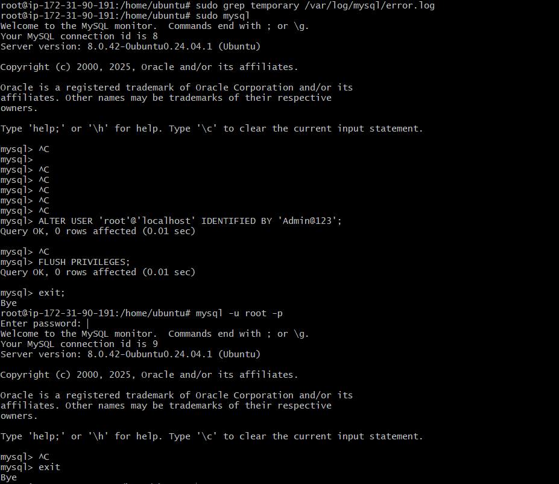

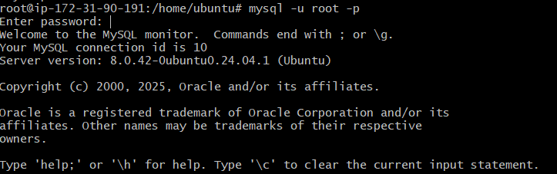

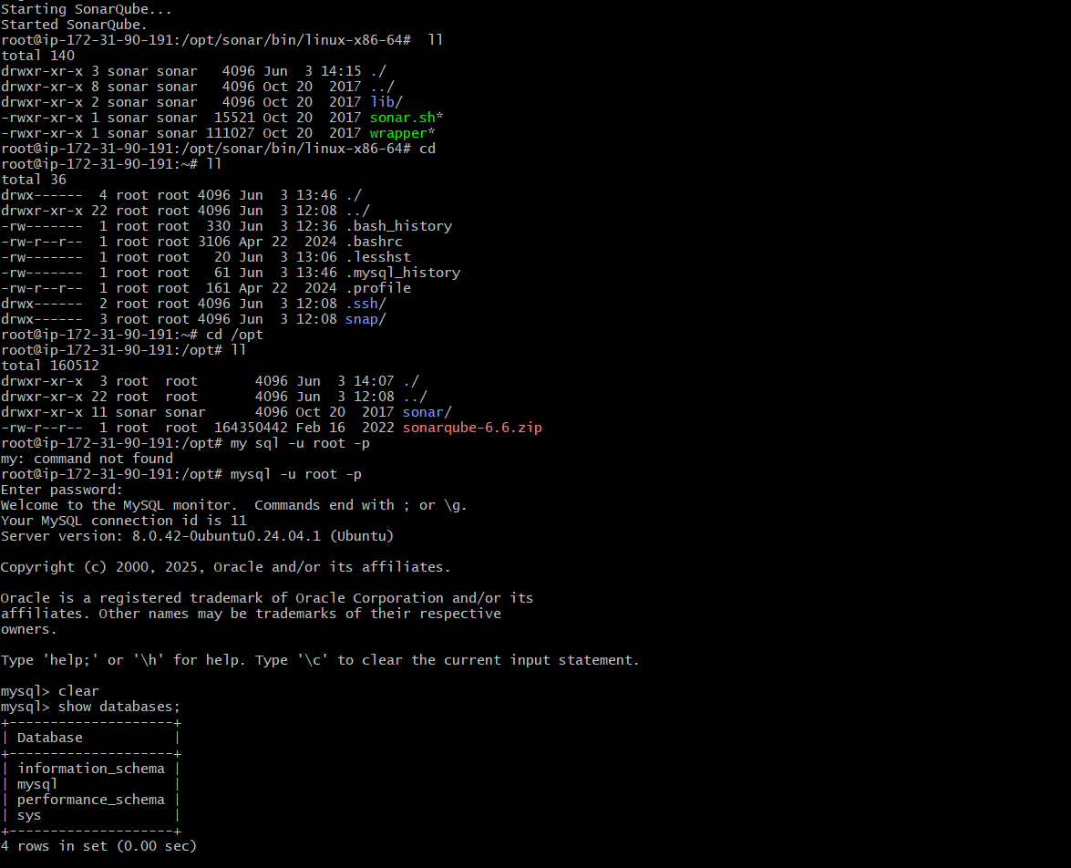

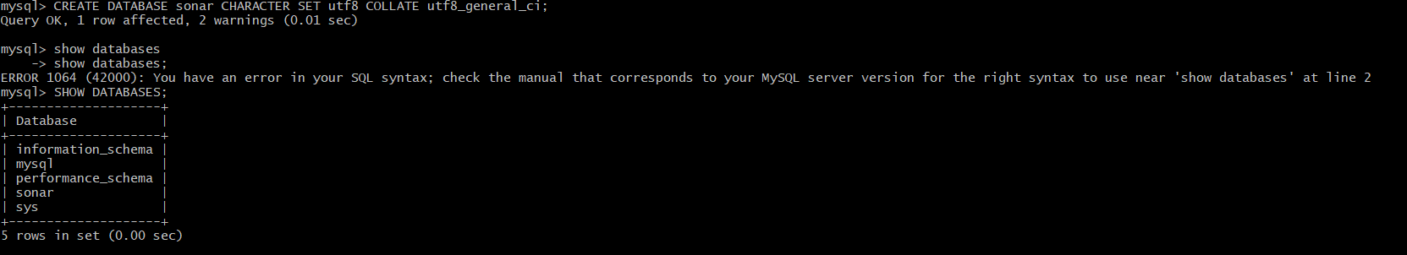

#!/bin/bash

# Exit on error

set -e

# Variables

SONAR_VERSION="10.3.0.82913"

SONAR_USER="sonar"

INSTALL_DIR="/opt/sonarqube"

SONAR_ZIP="sonarqube-${SONAR_VERSION}.zip"

SONAR_URL="https://binaries.sonarsource.com/Distribution/sonarqube/${SONAR_ZIP}"

# Update system and install Java 17

echo "Updating system and installing Java..."

sudo apt update -y

sudo apt upgrade -y

sudo apt install openjdk-17-jdk wget unzip -y

# Create SonarQube user

echo "Creating sonar user..."

sudo useradd -m -d $INSTALL_DIR -s /bin/bash $SONAR_USER || true

# Download and install SonarQube

echo "Downloading SonarQube..."

cd /opt

sudo wget -q $SONAR_URL

sudo unzip -q $SONAR_ZIP

sudo rm $SONAR_ZIP

sudo mv sonarqube-${SONAR_VERSION} sonarqube

sudo chown -R $SONAR_USER:$SONAR_USER sonarqube

# Configure system limits (recommended for production)

echo "Setting system limits..."

echo "sonar - nofile 65536" | sudo tee -a /etc/security/limits.conf

echo "sonar - nproc 4096" | sudo tee -a /etc/security/limits.conf

# Set up SonarQube as a service (manual mode first)

echo "Starting SonarQube..."

sudo -u $SONAR_USER bash -c "$INSTALL_DIR/bin/linux-x86-64/sonar.sh start"

echo " SonarQube installed and started."

echo " Access it at: http://<your-ec2-public-ip>:9000"

chmod +x install-sonarqube.sh

sudo ./install-sonarqube.sh

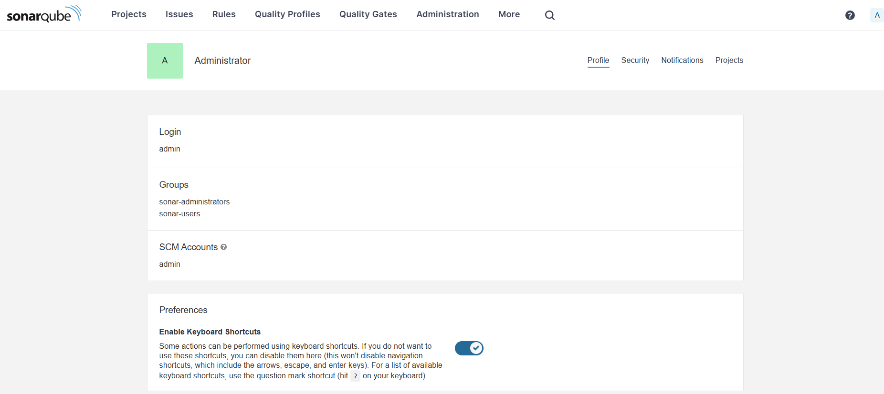

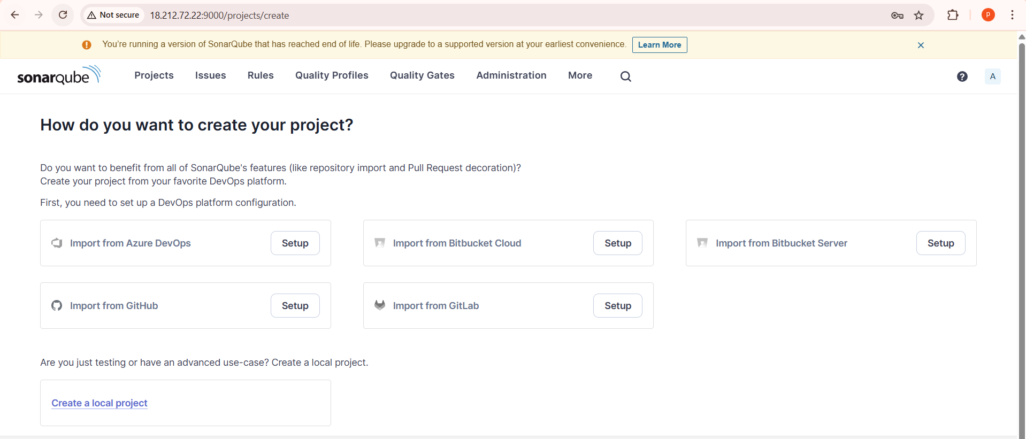

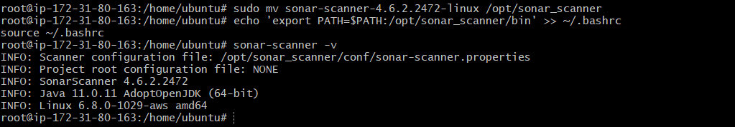

SonarQube Integration with Jenkins  
 Integration SonarQube server with Jenkins is necessary to store your   
reports.  
Follow below steps to enable that.  
For any integration we need to install the Plugins first  
 Go to Jenkins server Dashboard from there select Manage jenkins  
Select Plugins--> Available Plugins--> SonarQube scanner  
This plugin allows an easy integration of SonarQube  
Helps for continuous inspection of code quality  
Install the plugin

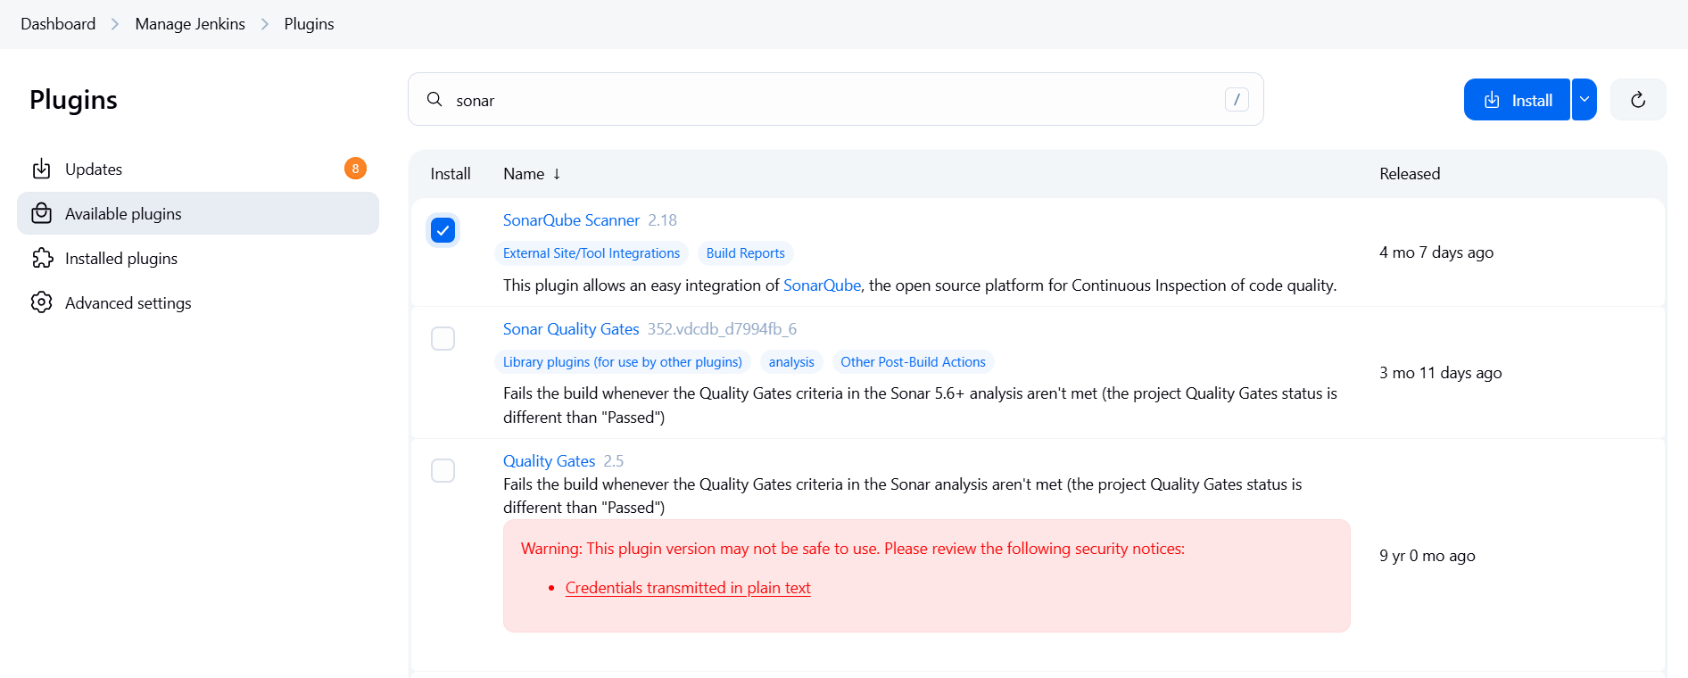

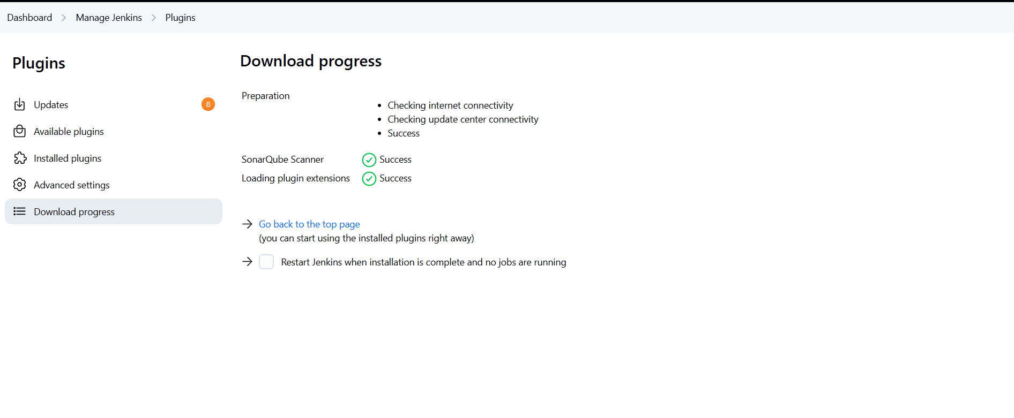

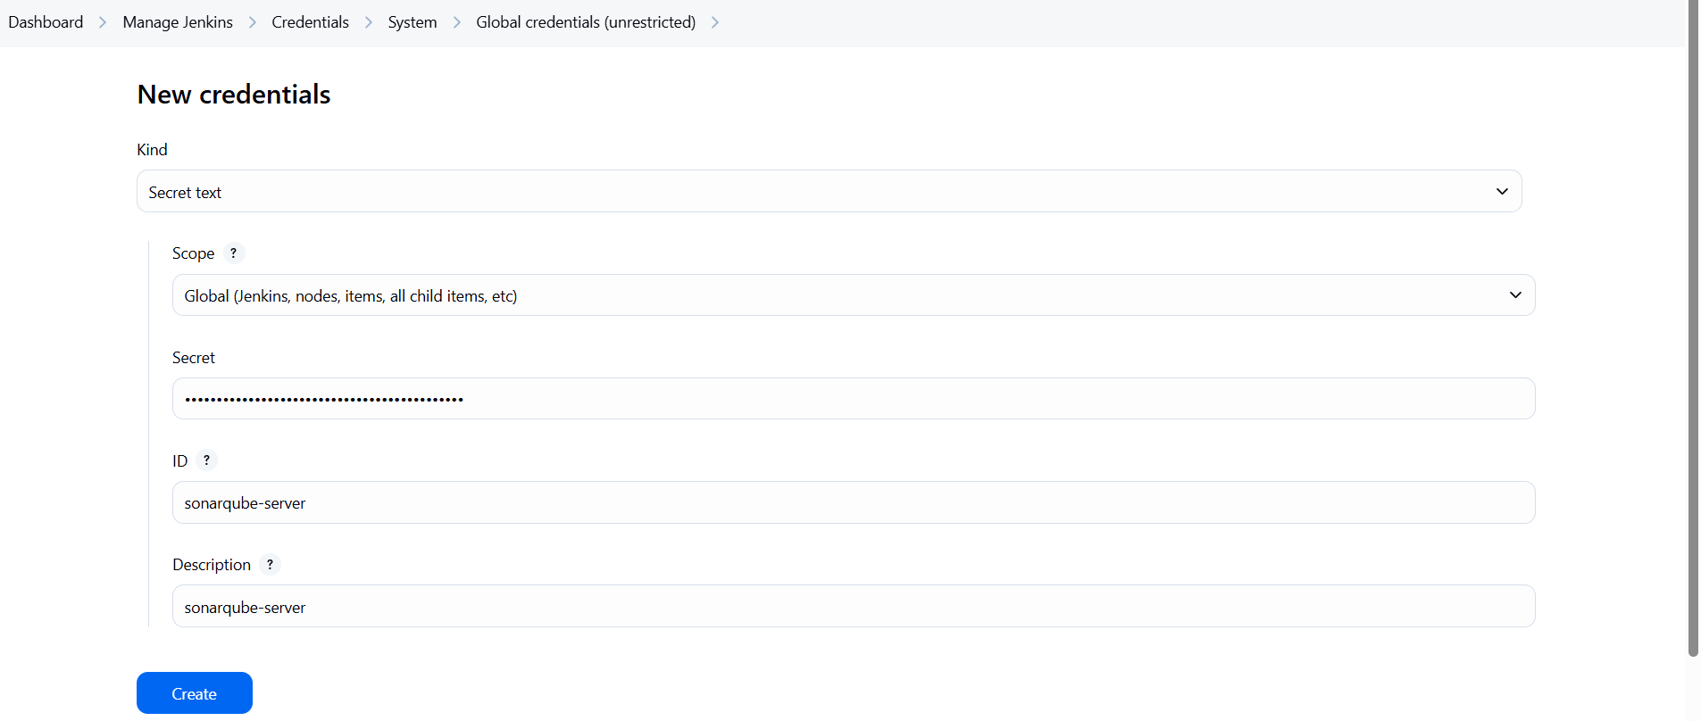

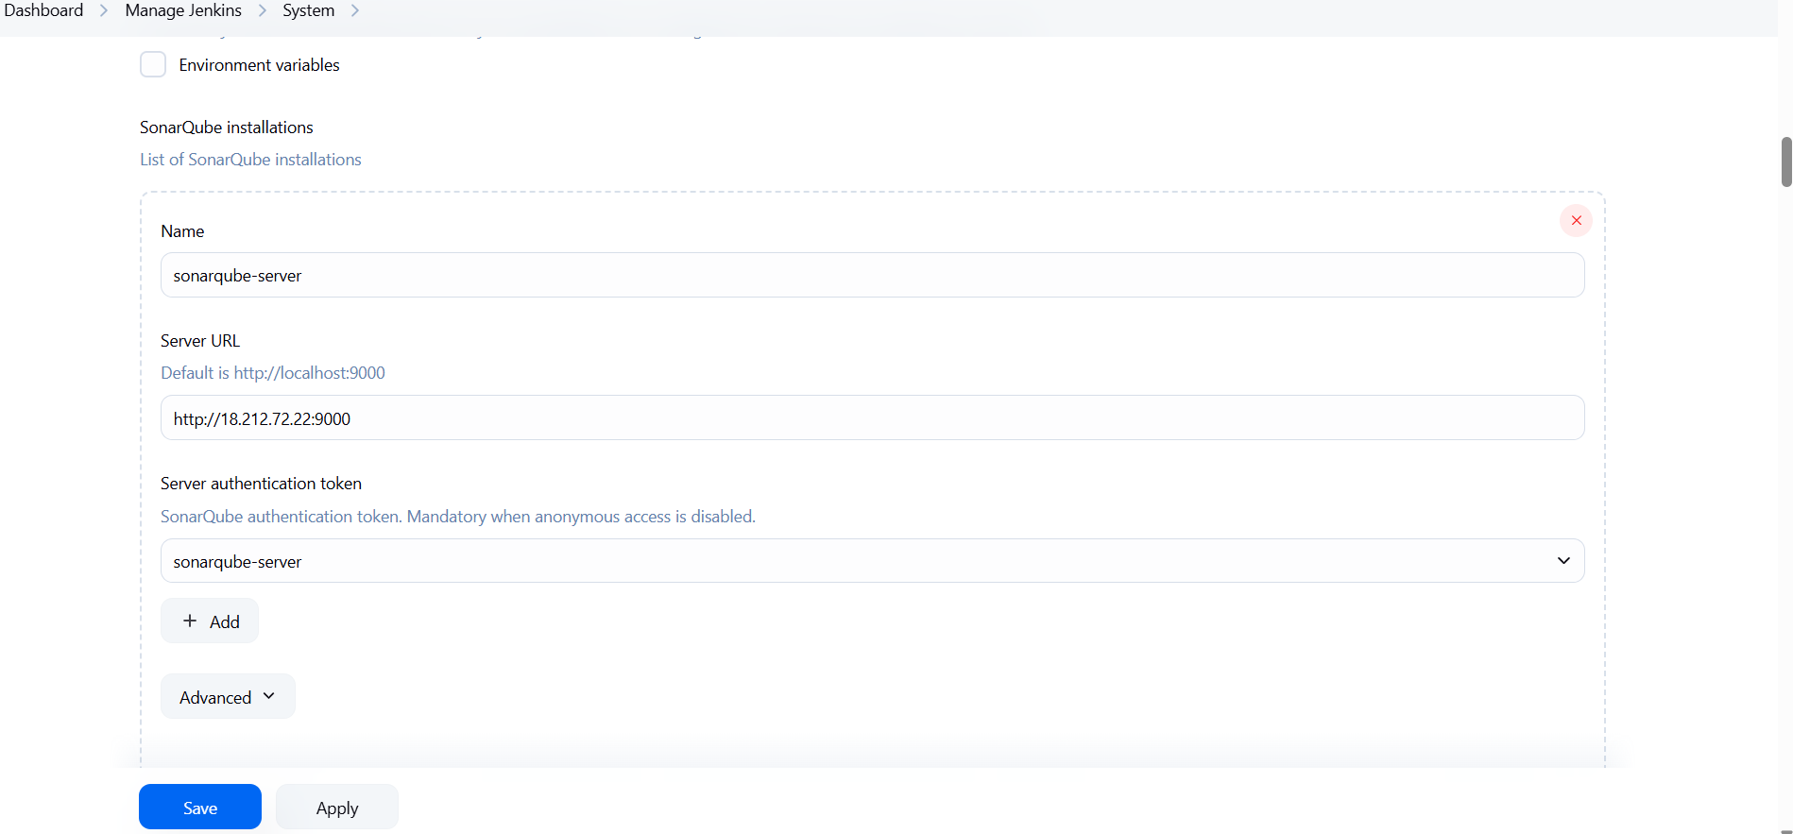

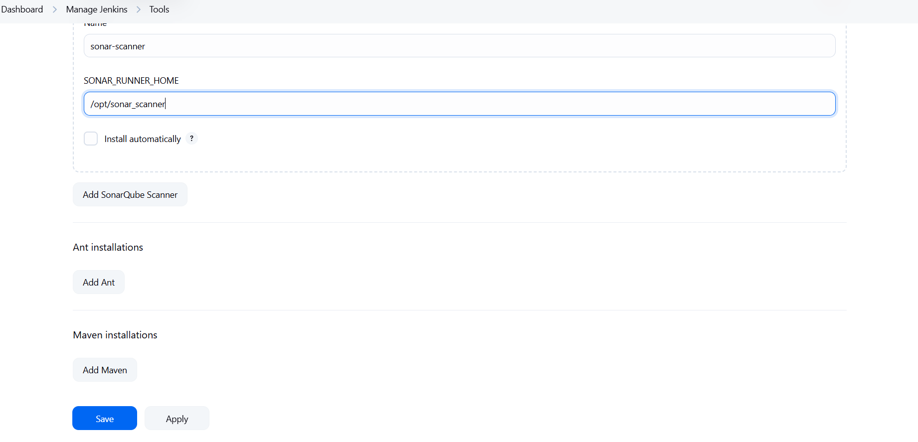

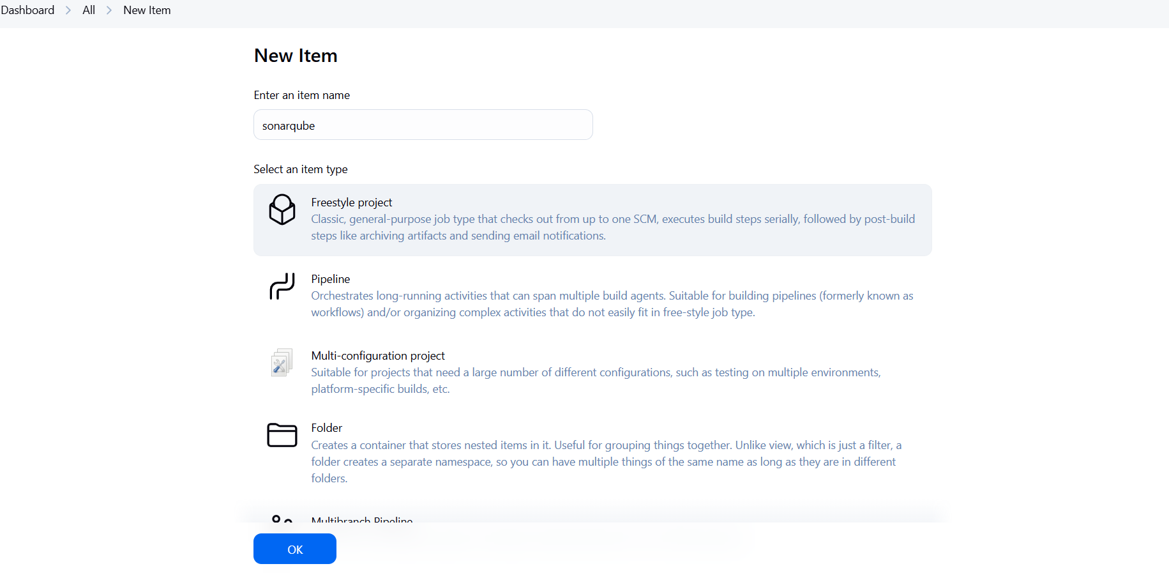

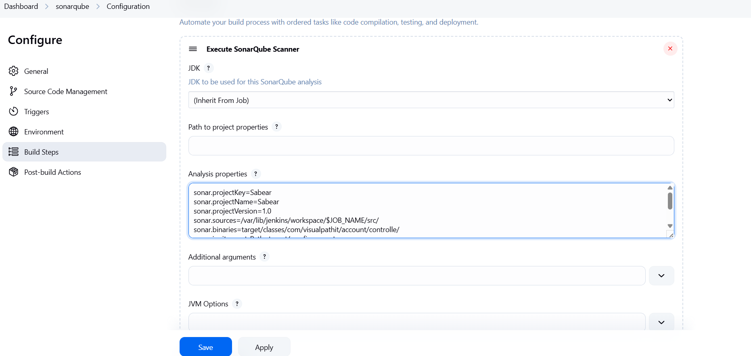

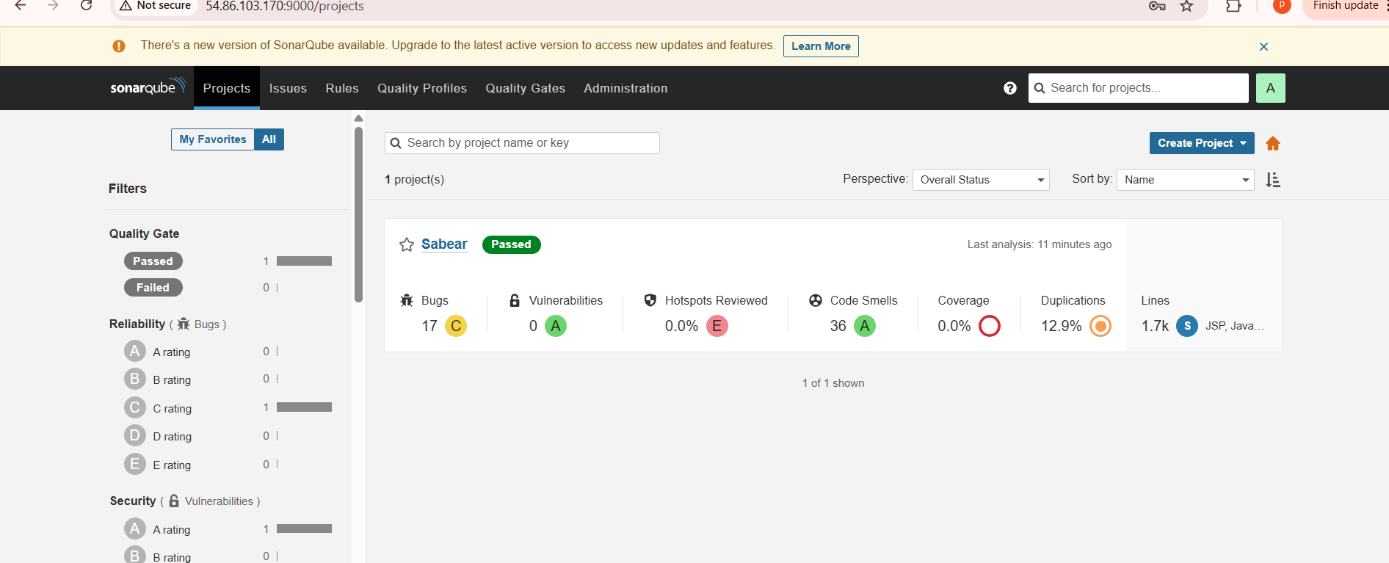

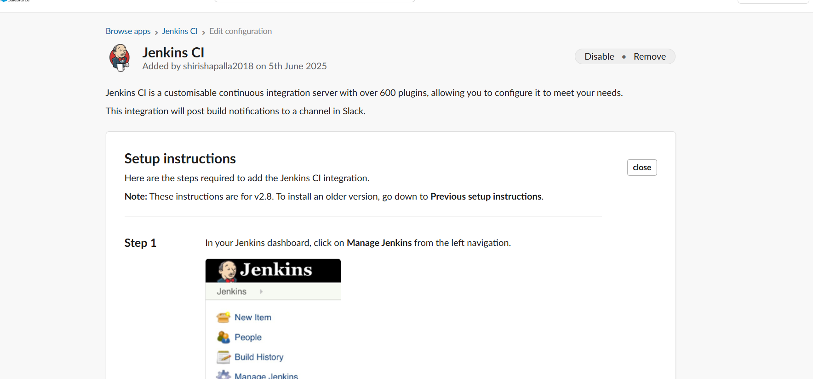

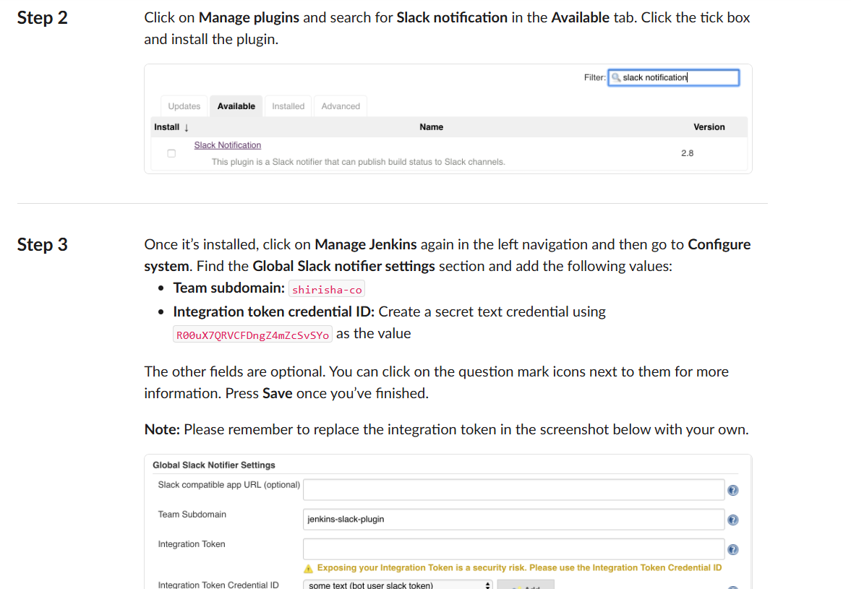

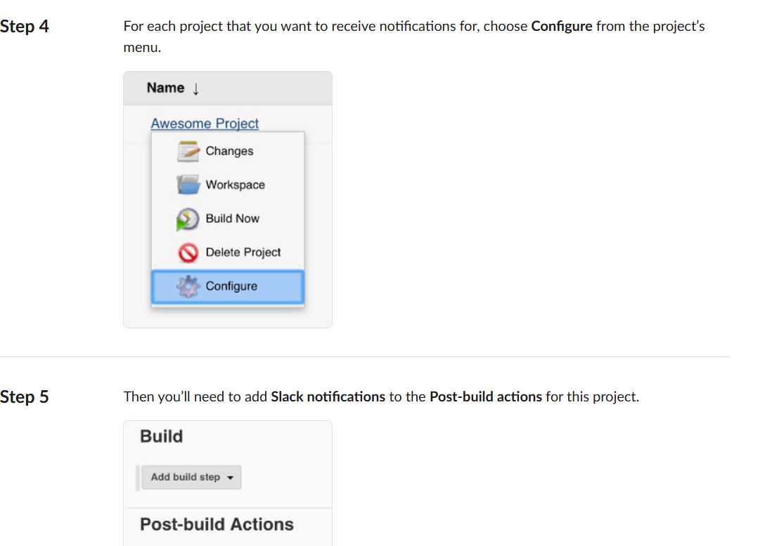

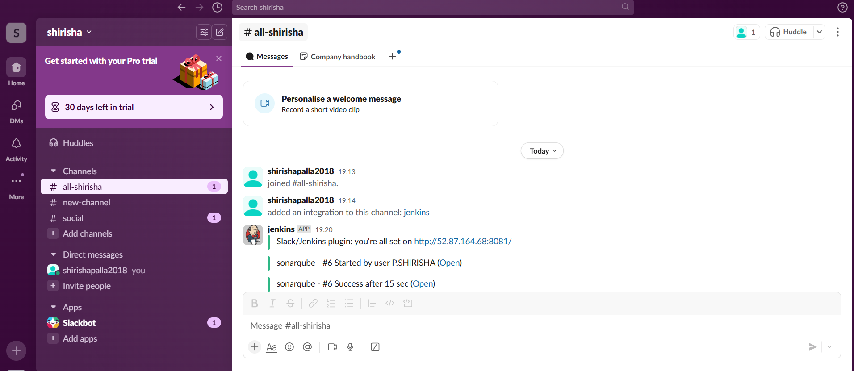

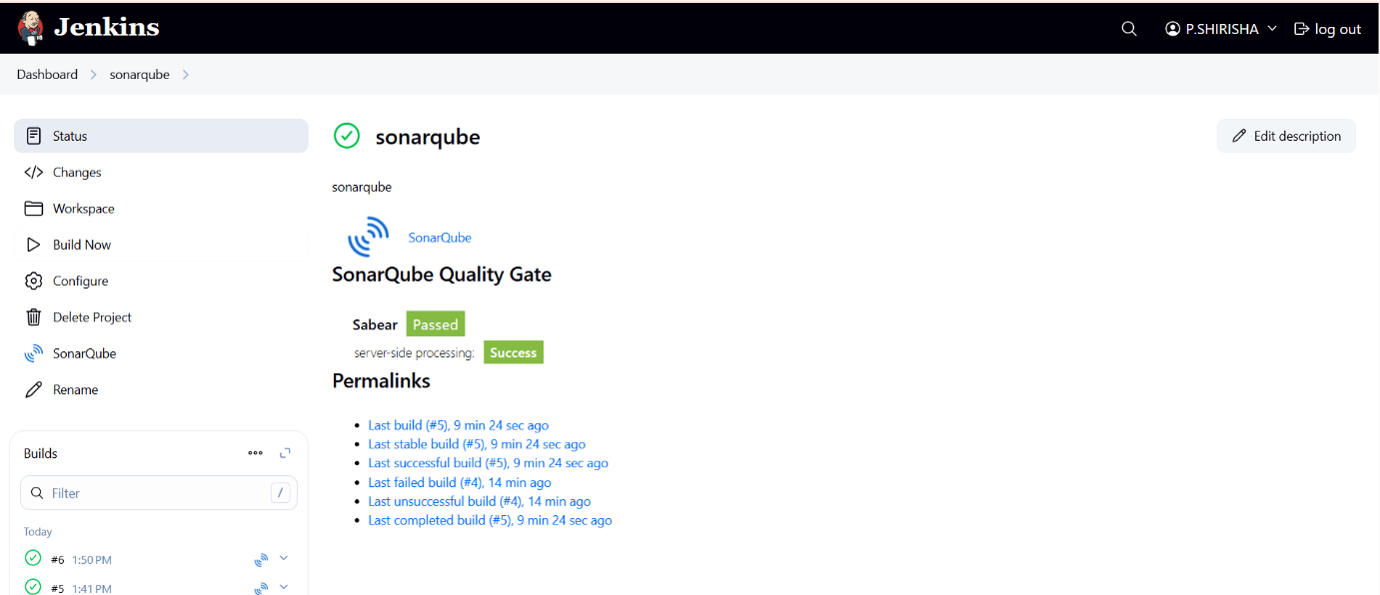  
**Another Method to setup SonarQube – Docker**

Go to SonarQube server: sudo su -

Yum –y install docker

Systemctl start docker

Docker pull Sonarqube

Docker images

Docker run –itd –p 9002:9000 sonarqube

Docker ps

We can see one container is running from docker images

Copy the public ip of sonarqube server:9002

We will be able to see the sonarqube dashboard

Now go to the sonar-scanner in jenkins server

Change the sonar-scanner properties and mention scanner.host.URL: sonarqube server ip:9002

Go to Jenkins server Dashboard -->manage jenkins-->system

Sonarqube installations: server_URL:9002

Create one token in sonarqube dashboard and update the token in credential

Now execute the job created

This time we can see the sonar_scanner will push the record to new sonarqube dashboard

To verify check the console output and sonarqube dashboard

Quality Gate passed

2) 1) Create one jenkins job using the below code and create three stages.

stage1: Git clone to download the source code.

stage2: Sonarqube Integration to check the quality of code

stage3: Slack Integration to send the alerts to slack.

URL: <https://github.com/betawins/hiring-app.git>

* All steps mentioned in 1st task

